SIMATS ENGINEERING
Department of Computer Science and Engineering

ASSESSMENT TOOL 3 – CODING CHALLENGE QUESTIONS
Course Code: | CSA12 | Course Title: | Computer Architecture
CO Assessed: | CO1 – Precision (BL4) | Assessment: | Coding challenge questions
Weightage: | 40% | Total Marks: | 100
CO1 Statement: | Analyse the functional units of a computer system including CPU, memory, bus structures, and I/O components by examining instruction execution cycles, addressing modes, and performance metrics such as CPI, clock cycles, and benchmarking
Student Name: | K.Rekanth | Reg. No.: | 192311213
Section / Batch: | 2023 | Date: | 29. 07.26

Instructions to Students
- Analyze the given scenario and identify the problem requirements before developing the solution.
- Design the algorithm or flowchart and select the appropriate 8085 instructions, registers, and addressing modes required for implementation.
- Develop and execute the 8085 Assembly Language Program (ALP) using a simulator or trainer kit to solve the given problem.
- Verify and validate the output by testing the program with the given input data and ensuring the expected results are obtained.
- Interpret the program execution by explaining the logic used, the role of registers, memory locations, flags, and the final output generated.

QUESTIONS
- An electronics manufacturer stores inspection results of ten products as binary values:
  - 00H – Defective
  - FFH – Accepted
Before packaging, the controller must determine the number of accepted and defective products. Write an 8085 ALP to
  - Count accepted products.
  - Count defective products.
  - Compare both counts and indicate whether production quality is satisfactory.

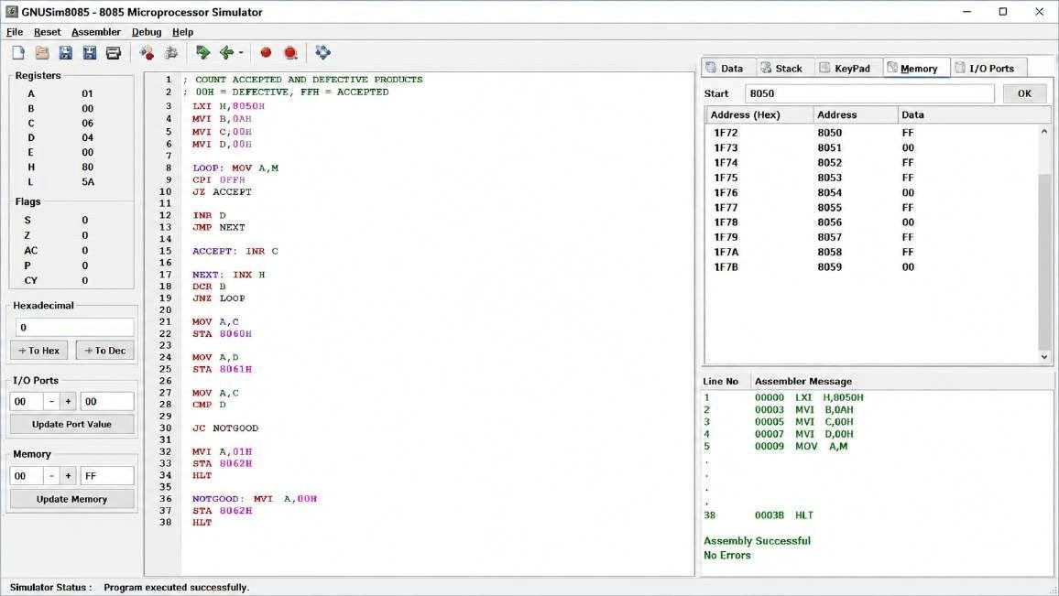

- A weather station records hourly temperature values in memory. The controller must determine whether the readings show an increasing trend. Develop an 8085 ALP that compares consecutive readings and counts how many times the temperature increased relative to the previous reading.

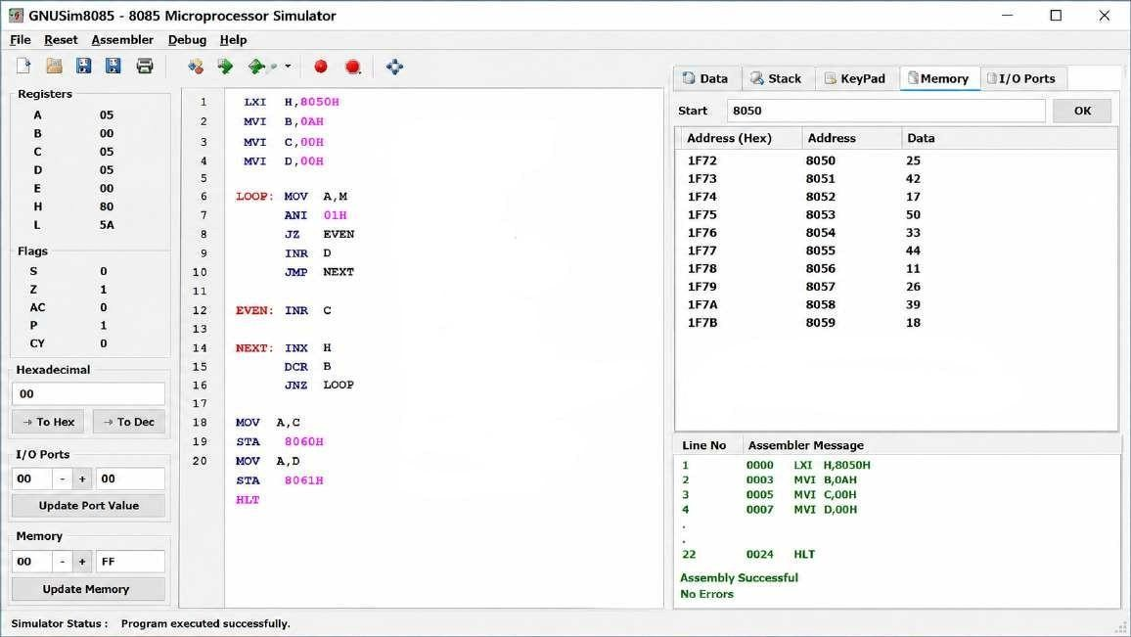

- A memory block contains a mixture of even and odd data values collected from different sensors.
For optimized processing, the controller must separate these values. Write an 8085 ALP to:
  - Count the number of even values.
  - Count the number of odd values.
  - Store the two counts in memory.

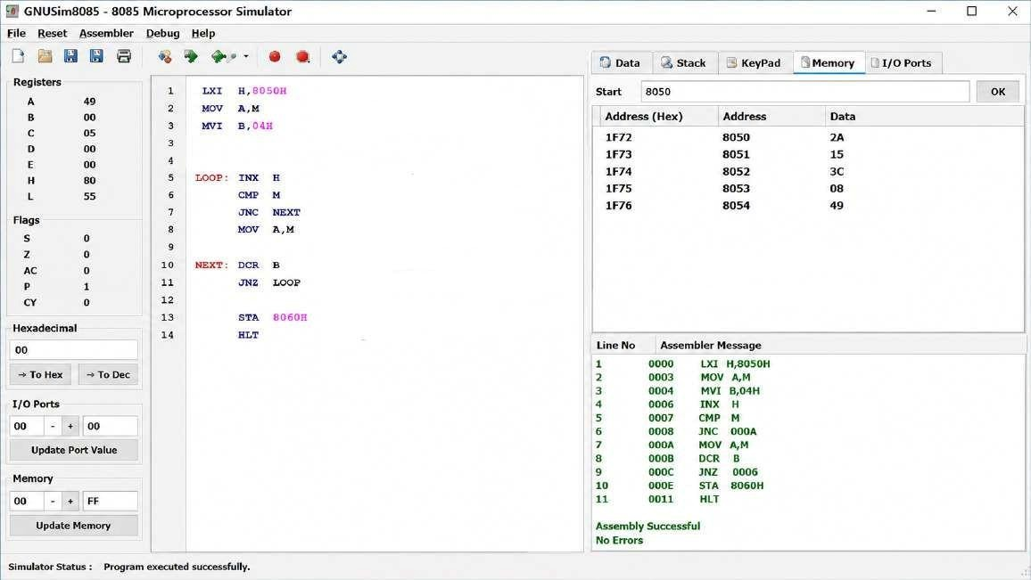

Code of Conduct
I K.Rekanth (192311213) (Name / Reg No) certify that this submission is my original work and that I have adhered to the guidelines specified for this assessment. I understand that any violation of academic integrity rules will result in disciplinary action.
Signature of the Student: __K.Rekanth__

RUBRICS FOR CALCULATION
Criteria | Weightage | Level 4 – Exemplary  (5 Marks) | Level 3 –  Proficient (4  Marks) | Level 2 – Developing (2–3 Marks) | Level 1 – Beginning (0–1 Mark)
Problem Understanding | 20% | Clearly understands problem  constraints, edge cases, and  competitive requirements | Understands problem with  minor gaps in constraints | Partial understanding; misses key constraints | Misinterprets problem or constraints
Algorithm | 25% | Selects optimal algorithm with  best time and  space complexity  for competitive constraints | Uses efficient algorithm with  minor scope for improvement | Uses basic/inefficient approach | No clear algorithmic approach
Code  Implementation | 20% | Writes correct, efficient, and  clean code that passes all constraints | Code works with minor errors or inefficiencies | Partially correct code; fails for some cases | Code does not execute or gives incorrect results
Competitive Performance | 20% | Solves problem within time limits and handles large inputs effectively | Solves within acceptable time with minor delays | Struggles with time limits or larger inputs | Unable to solve within time constraints
Test Case Handling | 15% | Handles all test cases including  edge and hidden cases | Handles most test cases | Misses important edge cases | Fails on multiple test cases

Marks Evaluation:

Q. No | Problem  Understanding  (20) |  | Algorithm  (25) | Code  Implementat ion (20) | Competitive  Performance  (20) | Test case handling (15) | Total (out of 100)
1 | / 4 |  | / 4 | / 4 | / 4 | / 4
2 | / 4 |  | / 4 | / 4 | / 4 | / 4
3 | / 4 |  | / 4 | / 4 | / 4 | / 4
 | / 20 |  | / 25 | / 20 | / 20 | / 15 | / 100

Course Coordinator Faculty Incharge

